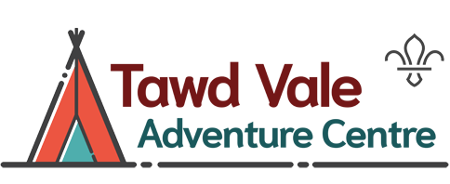
Tawd Vale Adventure Centre
Risk Assessment – Mini Crossbows
Date of Risk Assessment | 27th May 2026 | Completed by | Pete Sturgess

Hazard | Likelihood of Risk Score  (1 = Not Likely to 5 = Very Likely) | Seriousness of Risk Score  (1 = No Risk to  5 = Very High) | Control Measures
Transfer of infectious diseases such as COVID-19, Norovirus etc | 1 | 1 | - PPE such as masks and visors available upon request.  - Cleaning kits containing sanitising spray, paper wipes and hand gel available upon request.  - Usage of above voluntary unless high rates when the Centre procedures will require their use.
Participants health | 1 | 1 | - All users must be in good health, able to partake in the activity.
Participants behavior | 2 | 1 | - It is made clear on activity related documentation that all groups must have an adult leader who is responsible for the behaviour of the participants.  - The Activity leader may refuse any poorly behaved participants a go. Consistent poor behavior may result in the participant being removed from the range or the session stopped.
Injury caused by ricochet or hit by dart | 1 | 2 | - All participants must tie long hair back.  - No participants allowed in front of shooting line.  - Netting surrounds range on rear of the targets to ensure that darts cannot easily leave the range.  - Only fire at soft archery target bosses  - Activity Leader will ensure 10Mtrs overshoot is clear and available
Manual handling | 1 | 2 | - Correct method for cocking and loading crossbow demonstrated by activity leader and observed throughout session.  - Smaller participants offered support in cocking the crossbow if deemed necessary.
Equipment failure | 1 | 2 | - Activity leader to check equipment before and during session.  - Damaged or non-functioning equipment to be reported to the Centre Manager.
Slips, trips and falls | 1 | 1 | - Activity Leader to manage movement behind the shooting line ensuring participants walk at all times.
 |  |  | - At least one adult must hold a current first aid qualification.

